**Midterm Report**

**Introduction:** In this hackathon application we can send gifts to friends based on corresponding event. And we can add events, edit the events, invite friends, add gifts and so many functionalities are there.

**Design:**

**Architecture diagram:**



**Class diagram:**



**Features:**

Adding events, editing events, adding gifts, displaying gifts, sending invitations to friends

**Database Model:**

Database Name:: Hackathon

Table: Add gifts

Columns: Productname, Eventname,ProductUrl,Description

Table: Events

Columns**:** “EventName, EventType, EventTime, Eventdate, Description, personname, person name2”

**Technologies used:**

1. C#.net

2. ASP.net

3. SQL Server

4. JQuery mobile user interface

**Web services used:** Amazon API

Some screen shots of application are listed below.

The below screen shot displays home page.

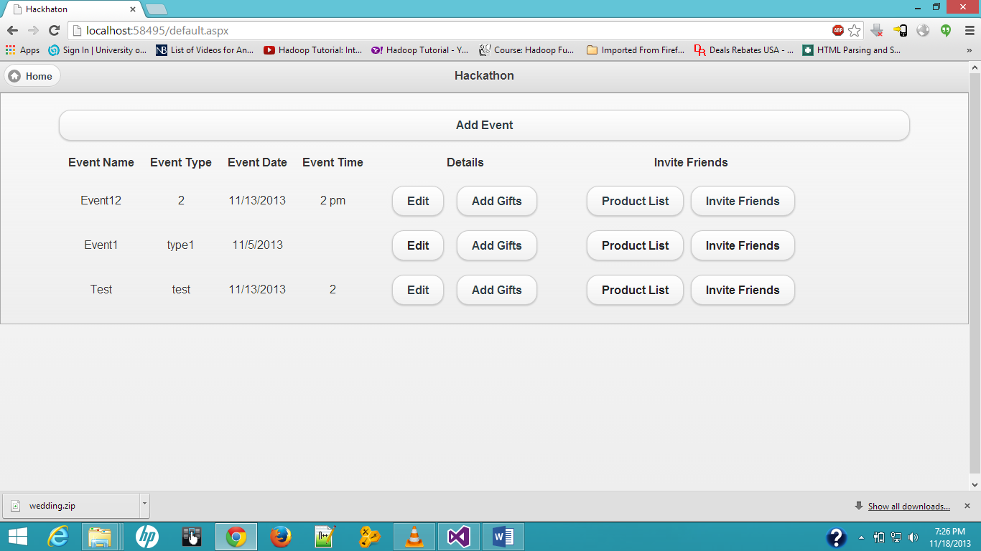

If you want to add event click on add event on home page then it displays below webpage .In this webpage we can specify event type, name, person name, location of event and date of event etc.

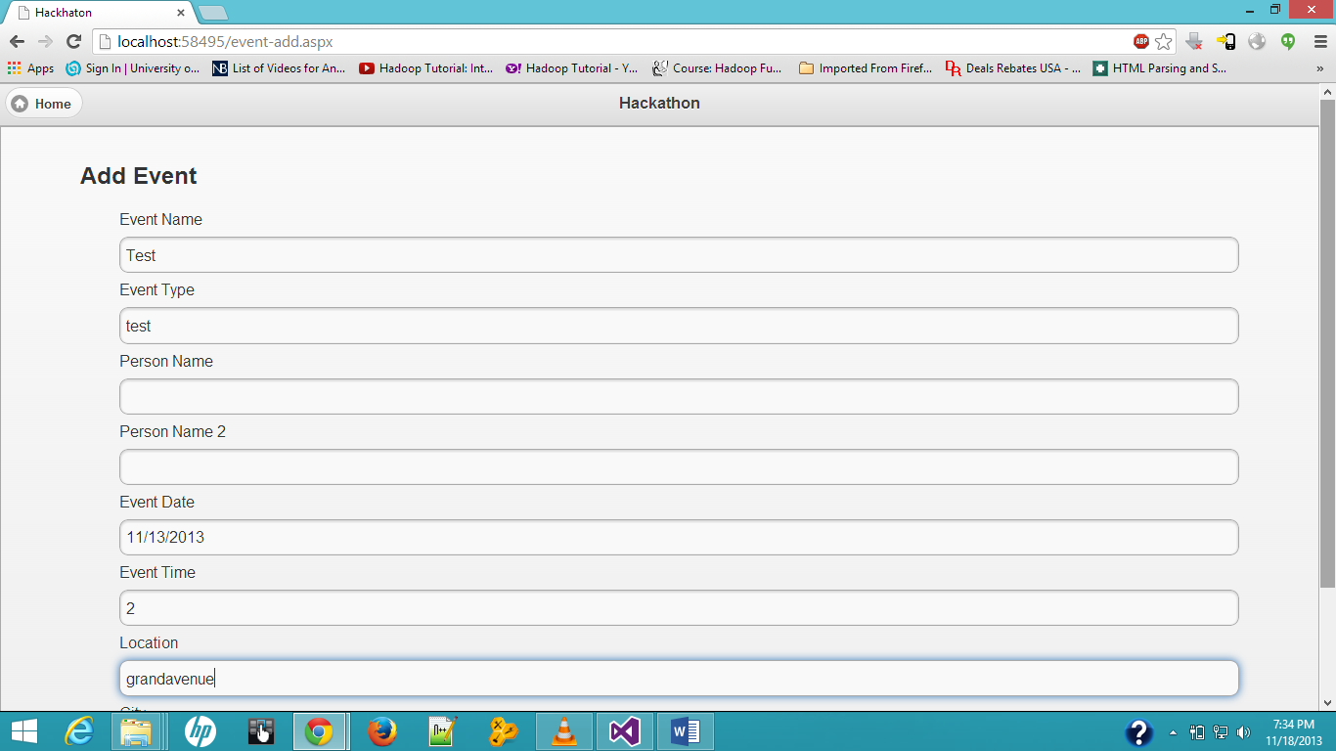

Incase if we want to edit event click on edit button on home page then it displays below webpage. Here we can edit event details like event type, name, person name and location details after editing all data then click on update button at the bottom of webpage then it updates event data.

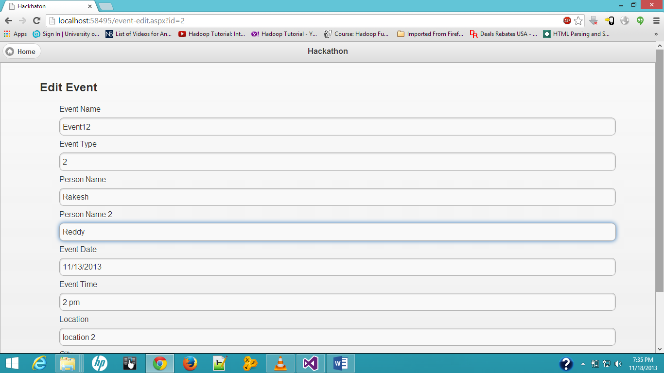

We can invite friends by clicking on invite friends button at home page then it displays below home page. In this webpage we can invite friends by using their email ids.

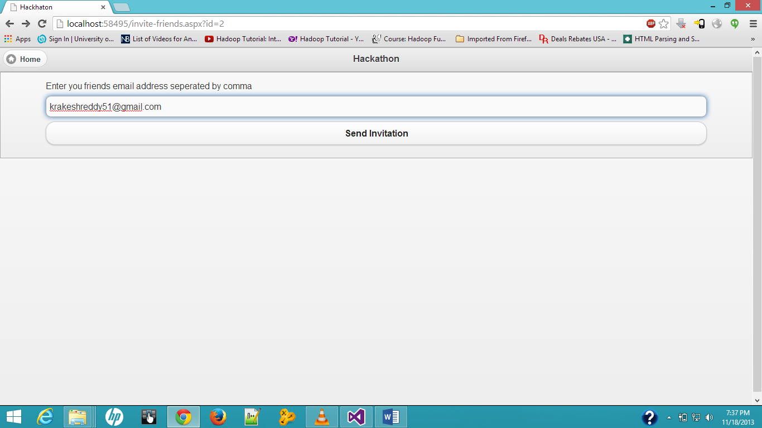

We can add gifts to event by clicking on add gifts at home page. Here we can specify product name, event name, product url, description. Then click on add button.

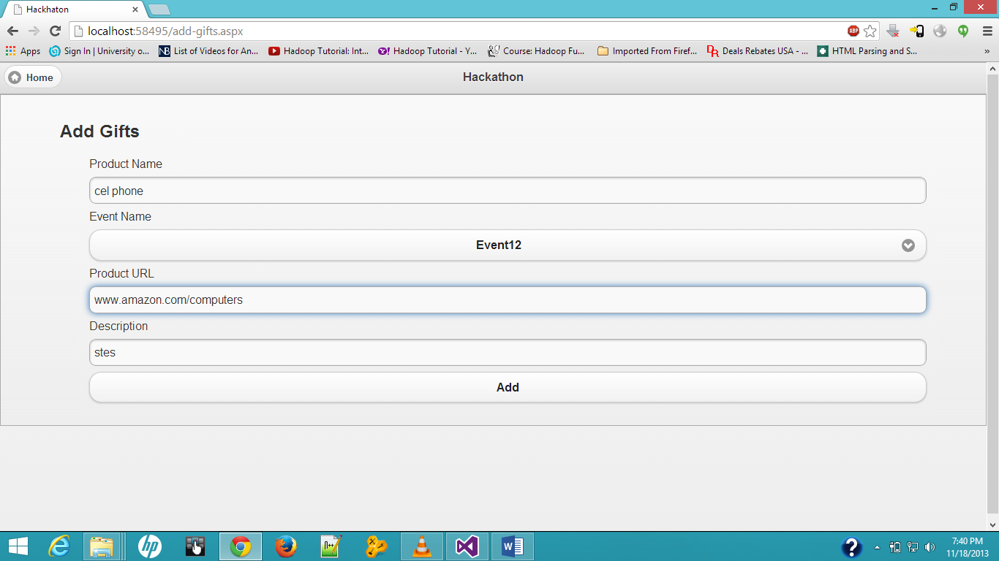

We can view product list by clicking on product list button at home page then it displays products and their description.

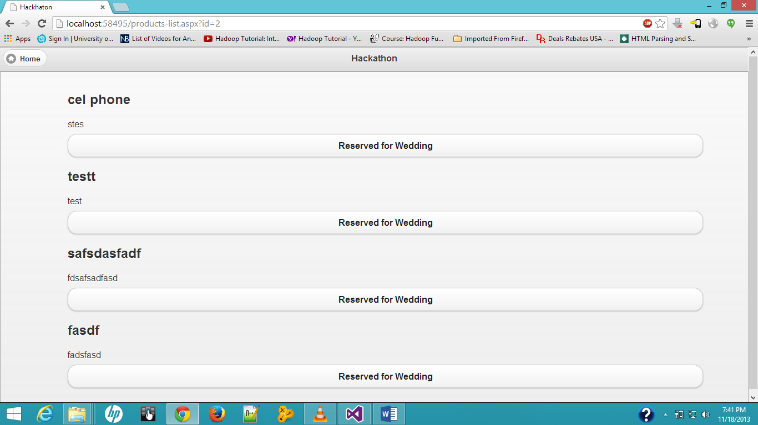

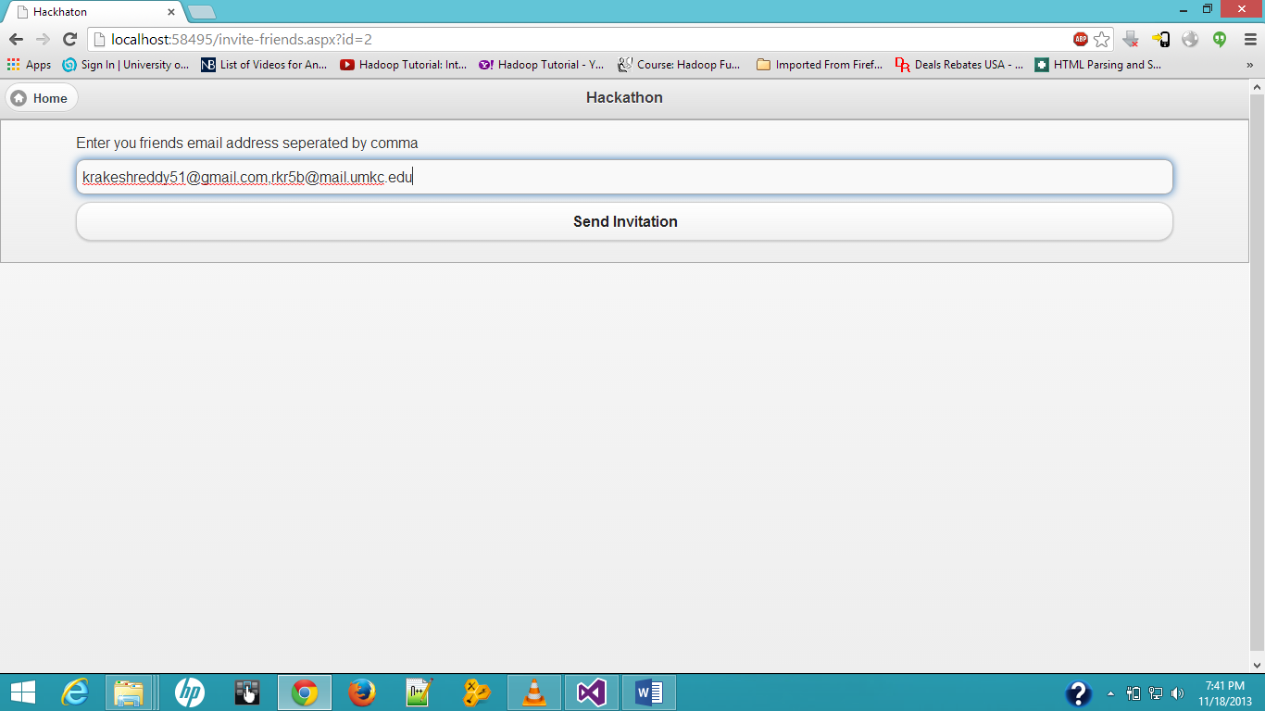

After sending invitation to friends your friends can view that to invitation.

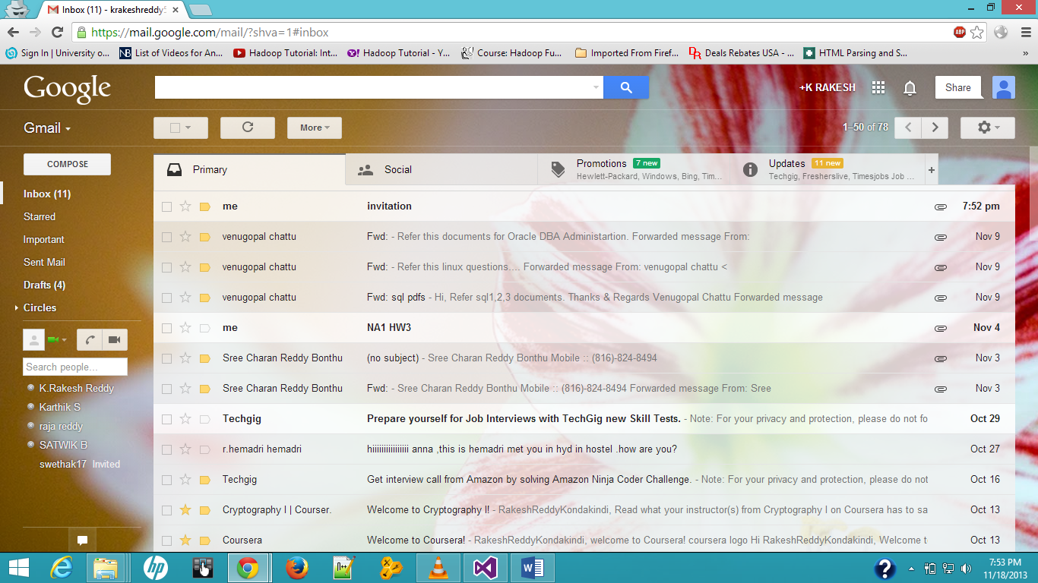

**References:**

[www.asp.net](http://www.asp.net)

[www.itlead.com.cn](http://www.itlead.com.cn)

[www.dotnetcurry.com](http://www.dotnetcurry.com)